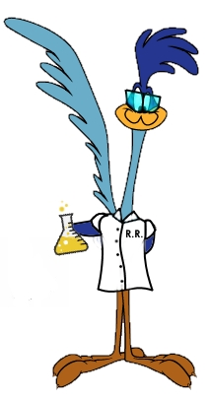
STEM Lab
Experiment #4: Pepper Scatter
Materials -
- Shallow dish or bowl
- Bar of soap
- Liquid dish soap
- Pepper
- Water
What to do -
- Pour enough water into the dish so that its about 1 inch deep.
- Sprinkle some pepper on top of the water.
- Make a hypothesis about what you think will happen to the pepper when you touch it with the corner of a bar of soap? What did happen? What happens when you take the soap away?
- Clean dish thoroughly so there are no traces of soap.
- Refill dish with water and sprinkle pepper on top as you did before. What do you think will happen if you add a drop of liquid detergent to the middle of the dish? Try it.
Why -
Water has a high surface tension which is why the pepper sits on top of the water when you sprinkle it into the container. High surface tension means all the little pieces of water called ‘water molecules’ are holding on and pulling at each other really strongly. The soap or detergent weakens those bonds. So when you drop the detergent on the surface of the water, the surface tension on that part of the water is reduced. The bonds between the water molecules farther away from where the drop landed are still strong so that area still has high surface tension. This leads to the force that pulls the pepper away from the detergent drop.

Extra-
- Try a drop of oil instead of liquid detergent. What do you think will happen? What about a drop of milk?
- Find a penny. Fill an eyedropper with water. Slowly add drops to the surface of the penny. What do you notice about the water? (Should be forming a dome of water). How many drops can you add before the surface tension breaks?

